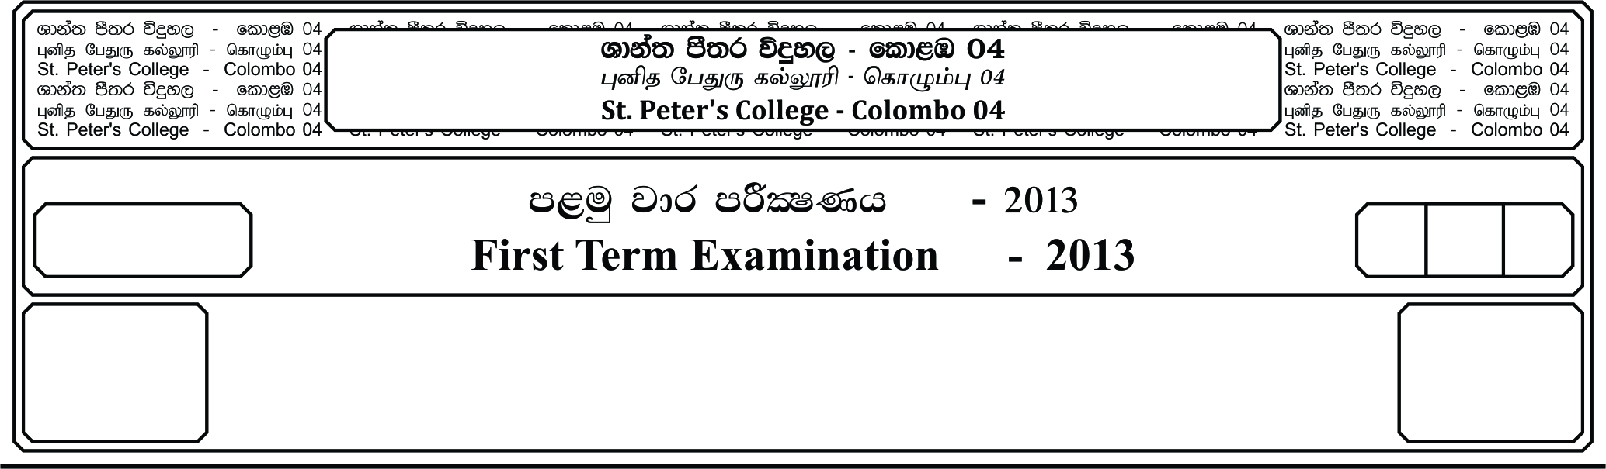

meh 3

three hour

10

E

ixhqla; .Ks;h

**Combined Mathematics**

12 fY%aKsh

GRADE 12

**;=kajk jdr mÍCIKh - 2020**

**Third Term Examination - 2020**

I

***Answer four Questions only***

1. a) Rationalize the denominator.

i)

ii) If find the value of

b) Express as a rational number.

i) ii) 0.12

c) Solve

d) Solve the simultaneous equations,

i)

1. a) The function f(x) is defined as,

i) Find the domain and the range of the function.

ii) Find f(4)

b) The function f(x) = X and g(x) = x +5

Find , i) ii) gf (x) iii) f1(x) (iv) gg (x)

c) Solve the equation.

d) Prove that,

Hence show that,

1. a) State the remainder theorem and prove it.

When the polynomial p(x) = is divided by (x - 1) the remainder is 2. When it is divided by (x + 1), the remainder is 3. Find *a* and *b*. Find the reminder when the P(x) is divided by (x - 1) (x + 1)

b). Express in partial fractions.

A

B

C

D

i. ii.

04. a) ABCD is a square of side 2a. Find

i. The length of the are BD

ii. The area of the BAD sector

iii. The area of the shaded region.

iv. The perimeter of the shaded region.

b). Find the values of the following,

i. 2 sin2 45 + 2 cos2 60 – tan2 60

ii. tan - tan + sin – sec

c). If sin = and in the 2ns quadrant, then find the value of

i. Cos ii.

d). Prove that, cos6 A + Sin6 A = 1 - Sin2 2A

05. a). Relative to an origin O, the position vectors of A and B are and respectively. Given that

i. Express in terms of and

A

B

C

D

E

O

ii. Express in terms of and

iii. Show that C, D and E are collinear

and find the ratio CE : ED.

b). The position vectors of A and B are - and + respectively.

Evaluate,

i. . and hence, find angle AB.

ii. . and hence, find angle OB.

e). Given that = - and = and the angle between and is 45o, find the

value of